MSIS 638

Case 2.1a

Jia Liang Ma

a)

Find at least three application of analytics in well-known companies (include references).

1. **Google**: App Growth Network

(This app is use by Google for Ads (Google UAC) Optimization)

1. **YouTube**:YouTube Analysis

(YouTube offers an in-depth offering for users to understand the video performance and for developers to evaluate brand watch consumer research)

1. **Trivago**: Trivago Frontend Engineering

(The goal of this application is to revamp the company's Business Intelligence web application)

References:

<https://www.brandwatch.com/blog/youtube-analytics-tools/>

<https://tech.trivago.com/2021/02/09/rethinking-the-next-gen-analytics-web-app-at-trivago/>

<https://tech.trivago.com/2020/10/22/deep-dive-into-data-science-at-trivago/>

<https://www.businessofapps.com/marketplace/app-growth-network/>

<https://www.mentionlytics.com/blog/5-real-world-examples-of-how-brands-are-using-big-data-analytics/>

<https://appgrowthnetwork.com/blog/how-to-make-google-play-game-apps-successful/>

<https://www.quora.com/What-types-of-data-does-YouTube-collect>

<https://blog.hootsuite.com/how-the-youtube-algorithm-works/>

b)

1. **Google:**

a. What is the specific real-world problem?

Customer reaching rate in advertisements, and product advertisements’ analytics and forecasting.

b. What are corresponding alternatives?

Google Ads App Campaigns (ads intelligence tool), Social Peta (ads intelligence tool for marketing strategy), Tenjin (advertising analytics)

c. What data is used?

Users web browsing history, Users preferences data, Gaming data, Consumer spending habits.

d. How is the relevant data obtained?

1.By collecting user’s computer and phone’s internet access, cookie and web browsing access. 2. Through Big Data collecting.

e. What mathematical model is used to analyze the data?

Key Performance Indicator (KPI), User Churn Rate, Session Length, Daily Active Users (DAU), Monthly Active Users (MAU), Average Revenue Per User (ARPU), MOST analysis

f. List and elaborate on two challenges of the analytical method used.

1. Daily active users data collection. For example, how to build common criterions between apps. Because the metric various significantly between mobile games and other categories of apps.

2. Challenge in session length is that the time that the user uses the app may also include the unslipping one. (still working in background)

g. Make at least two suggestions to improve the analytical method used.

1. To improve the DAU, we can set up a common indicator and a separate category of indicators for different categories of apps.

2. For monthly active user (MAU), to improve the accuracy of measuring the number of mobile users who open an app monthly. Company can pay more attention to commonly used programs by users.

2. **YouTube Analysis:**

a. What is the specific real-world problem?

How to utilize the performance of users’ videos and turn them into business insight. Also planning strategy for targeted customers.

b. What are corresponding alternatives?

Using another analytics tool available for YouTube (ex, BuzzSumo – a YouTube Analyzer tool)

c. What data is used?

Brand overview data, total views and watch time of the video, comments and detailed description data, User preference data (ex, Recent YouTube searches and videos you have watched), User basic information (ex, Name, gender, phone number), Estimated revenue. 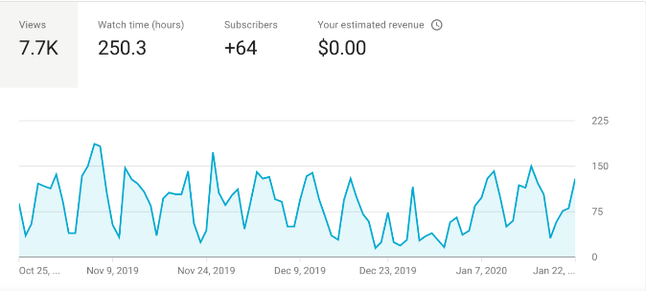

d. How is the relevant data obtained?

By YouTube data collector, associated with Google’s data for user.

e. What mathematical model is used to analyze the data?

YouTube and Google algorithms, Average Revenue Per User (ARPU), Active User (AU), Recommendation system, PESTLE analysis

f. List and elaborate on two challenges of the analytical method used.

1. Whether the preference video dataset have outlier or not - This will be a factor which affected the outcome of the analysis. (ex, sometimes you may receive some weird video recommended by YouTube)

2. The accuracy of clients’ targeted customers. (Advertising intensity)

g. Make at least two suggestions to improve the analytical method used.

1. Improve machine learning in reading user history and content, making better analysis about user preference.

2. Enhance the detector for video features and cross comparison other candidate sources.

1. **Trivago Frontend Engineering**:

a. What is the specific real-world problem?

How to maintain performance during the period of COVID-19 outbreaks.

b. What are corresponding alternatives?

Other metasearch engine, especially a will-performance search engine.

c. What data is used?

User churn and increase rate, Recommendation system, User preference (Coupon and trip arrangement), User journey and story line.

d. How is the relevant data obtained?

Through A/B test, Big Data Collection, Data Wrangling/ETL (Getting data to a usable format is a challenge in and of itself.)

e. What mathematical model is used to analyze the data?

Machine learning model, Cost-Per-Click business model (CPC), Rethink user journey.

f. List and elaborate on two challenges of the analytical method used.

1. Selector’s accuracy (Trivago adopted a store-first approach that puts state management at the center of the application. They created a single-directional data flow and defined a clear relationship between the data layer and the user interface. In this way, an accurate selector will help them match the optimal solution for customers.)

2. High quality output even during the pandemic (It is a real-world challenge for many industries that how they can generate profit even survive during the COVID-19 outbreaks.)

g. Make at least two suggestions to improve the analytical method used.

1. Increase more data storage space for the Trivago Frontend Engine to cache data. This will reduce the time of searching and matching the hotels with the demand.

2. Improve the algorithm of recommending system, creating stable retention rate of customers.